
សកលវិទ្យាល័យភូមិន្ទភ្នំពេញ

ROYAL UNIVERSITY OF PHNOM PENH

ប្រធានបទរបាយការណ៏ស្រាវជ្រាវ

The topic that my group, Stung Areng Ecotourism Community, studied was a tourist site in Thmar Bang district, Koh Kong province.
- Our project was researched by a group of students from the Royal University of Phnom Penh, who are in their third year of the Department of Information Technology Engineering. 2 members.

Our Teams

Tith Sure

Khorn Seyha

Norng Pisey

CHAPTER 1 INTRODUCTION

  - Background to the Study
We decided to do this project because I saw a lot of tourist sites that are located far away and not very familiar, and some people find it difficult to find places to visit, especially for those who like. Hiking, especially in remote areas And in the mountains. because I see that today technology is very advanced and most people are using technology to communicate, search for information and so on, so I think technology. Can promote two tourist sites.
1.2 Problem Statement
For use, I have divided the problem into two categories.
- Creator:
He can enter information related to tourist sites, services in the community, areas to visit, travel, they can add to many other information available in the community that he wants to spread.
- Users:
His users can access and read the details of each tourist site in the advertisement, will be able to see the location of the community. and those areas, he can also select the area and services that he binds, and he can Contact the community to ask for more information.

1.3 Aim and Objectives of the Study
We created this website to promote and give users access to two tourist attractions in the Areng community. Can be used on both phones and computers, will have a wide range of functions, he can use anywhere and anytime. For our site, one person can create only one and the usage limit is only for sites with internet access.
For Limitation, we do for the Web only.
As for our website, it is easy for users to use it anytime, anywhere, as long as there is internet service, especially there is no long time to access it, there is not much complexity, it will get you trust. Mind too.
1.4 Rationale of the Study
Through research as well as two surveys, people who have visited the Areng area find it difficult to travel, spend long hours searching for information, and have difficulty communicating with the community. Because those areas are far away, it is difficult to visit when he wants to visit there, he has to spend a lot of time searching for community information and inquiring about the hall so he can travel.
1.5 Limitation and Scope

Author | Method/Topic | Description | Result
Sabay News | Web development | Provides a lot of convenience to users | They provide information every day
Stung Areng Ecotourism Community | Web development | ​In order to make the tourist area more famous, it is necessary to promote local tourism | The more you know about the Areng area, the more people will visit.

The Stung Areng Community Ecotourism Website was created by a student of the Royal University of Phnom Penh who is in his third year of Information Technology Engineering.
Our website promotes Areng tourist sites that provide convenience to those who wish to visit there. They can access various information available in the community. If they need more information, they can contact us directly by phone or email to find out more about various community services so they can arrange to ensure the safety of passengers.

  - Structure of Study

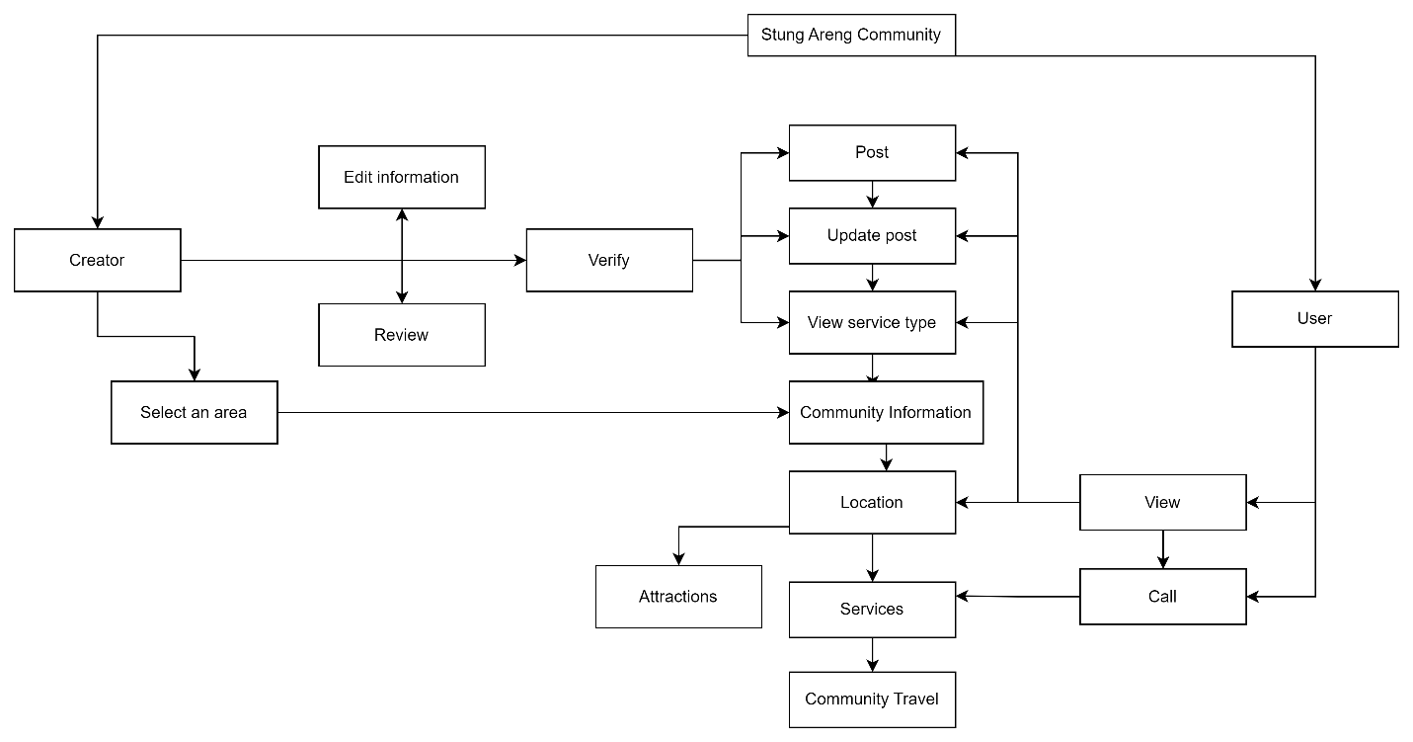

CHAPTER 2 LITURATURE REVIEW

2.1 The Definition of Wilderness
Websites are created to promote various consumer products. In particular, we have seen websites that spread a lot of information, such as Sabay News, which was created for the purpose of disseminating knowledge, as well as a lot of information organized by the Sabay News team. They can advertise entertainment, news, music, art and more.
Because we see a couple of things that many websites have not done yet to advertise the two newly discovered tourist sites in remote and lesser-known areas such as Areng.
2.2 Wilderness Values
We have already seen that it is very important to set up this website to promote two tourist attractions in the entire Areng ecotourism community that will be known and visited.
2.2.1 Natural/Biological Values
Our site would like to mention two tourist sites, Stung Areng, which is far from the city and will not know much about this area, especially with beautiful scenery and beautiful natural forest for tourists.
Our website is designed to make it easier for those who want to know about these attractions, especially to promote the forest as well as the tourist area and help preserve both beautiful forests.
2.2.2 Cultural Values
We created this website in order to help the local tourism industry to become more popular and promote tourism in Areng area in Koh Kong province to know more people because it is rich in natural forests and ancient tourist sites. It will help preserve the forest. And those areas.
2.3 Tourism and Wilderness Areas
In our site we have included many tourist attractions in the entire Areng community, as well as travel, services and local locations such as mountains, waterfalls and campgrounds. But with all the beautiful scenery, those locations in two different places will have the means of transportation of our choice.
2.3.1 The Growth of Tourism
Many tourist sites are advertised, especially in remote areas to visit and visit all those destinations, especially to help promote. The community economy also contributes to the protection of many forests.
2.3.2 Management of Tourism in Wilderness Areas
These tourist sites are managed by the Stung Areng Ecotourism Community, which was established in 2015, which has made these tourist sites beautiful and well-known, especially with the services provided.
Stay safe for those who have visited there, as well as the valuable natural resources that have helped to preserve it.
CHAPTER 3 METHODOLOGY

3.1 Research Design







Tools
- BY Internet
- W3 School
- HTML Programing
- CSS Programing
- Adobe XD
- Visual Studio code
- Live server
- Untitled Diagram.drawio

3.1.1 Study Population
The web browser available in Android and IOS is based on the open-source layout engine, coupled with Chrome's and google engine supporting HTML5​, CSS, Visual and live server.

